Create a Virtual Machine with 1 CPU, 2GB RAM and 15GB storage disk using a Type 2
Virtualization Software, using virtual box.
Aim: To create a Virtual Machine with 1 CPU, 2GB RAM, and 15GB storage disk using a Type-2 Hypervisor (VirtualBox).
Procedure:
- Install and open Oracle VM VirtualBox on your computer.
- Click on New to create a new Virtual Machine.
- Enter the Name of the VM (e.g., Ubuntu/Windows) and select the Type and Version of the operating system.
- Click Next, then allocate 2GB (2048 MB) RAM in the memory size dialog box.
- Click Next to configure the VM's hard disk.
- Select Create a virtual hard disk now and click Create.
- Choose the hard disk file type (e.g., VDI – VirtualBox Disk Image) and click Next.
- Select Dynamically allocated for flexible storage usage and click Next.
- Set the storage size to 15GB and click Create.
- After creation, attach an OS ISO file and finally start the VM to begin installation.
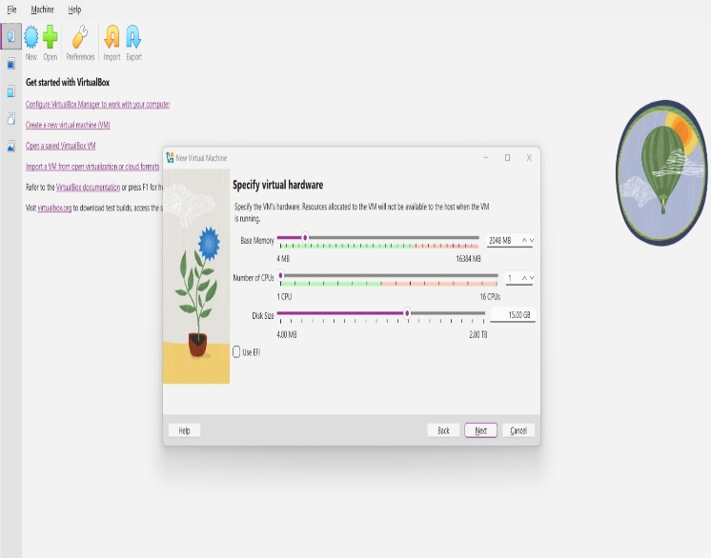
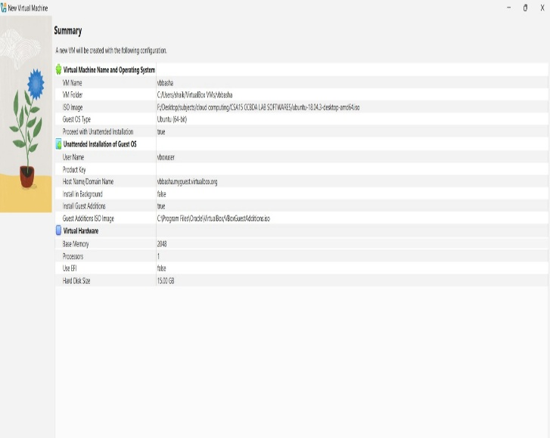
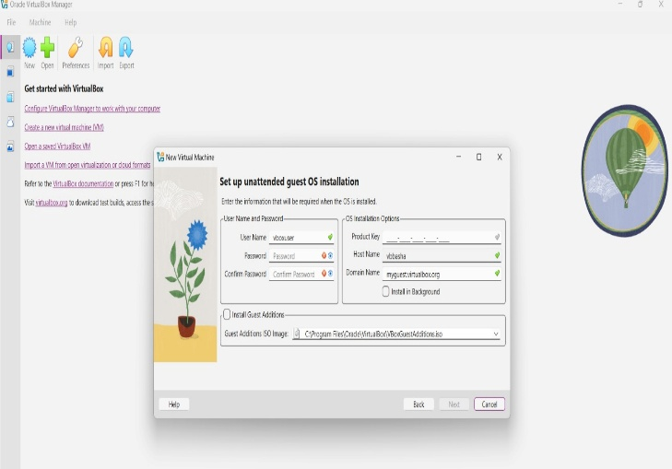
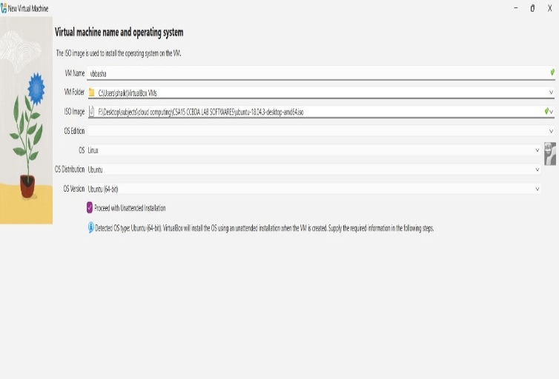
Output:
Result : A Virtual Machine with 1 CPU, 2GB RAM, and 15GB storage capacity was successfully created using Oracle VirtualBox.

